Peripherals and Power Supply
ASSIGNMENT 1 DAY2
TASK1. List 3 real-world devices in your home or college that use SMPS (Switched Mode Power Supply) and 2 devices that use UPS (Uninterruptible Power Supply), explaining in one line why each device needs that type of power supply.
SMPS (Switched Mode Power Supply):-
Device | Uses
Desktop Computer | SMPS converts AC power into multiple DC voltages (+3.3V, +5V, +12V) efficiently.
LED Television | SMPS provides stable power with low energy loss and compact size.
Wi-Fi Router | SMPS supplies regulated DC power while consuming less electricity.

Devices Using UPS (Uninterruptible Power Supply):-
Device | Uses
Desktop Computer | UPS prevents sudden shutdowns and protects data during power failures.
Network Router/Switch | UPS keeps the internet and network running during power outages.

TASK2.Draw and label a diagram showing the main internal components of a typical SMPS unit found in a desktop PC, including AC input, rectifier, transformer, and DC output sections.<br><br><em><strong>Hint:</strong> You can hand-draw and upload a photo, or use any free diagram tool like draw.io.</em>
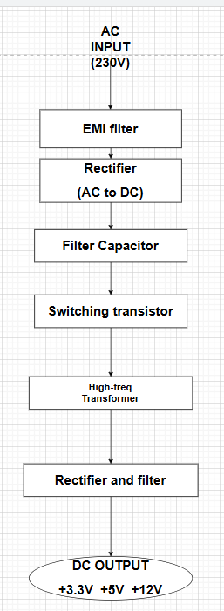

TASK3. Take photos or find clear images online of the following power connectors: ATX 24-pin motherboard connector, SATA power connector, Molex connector, and PCIe 6/8-pin connector. For each, write its name, the devices it powers, and one safety tip for connecting/disconnecting it.
- ATX 24-Pin Motherboard Connector
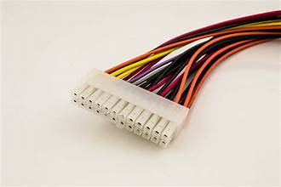
Purpose: Powers the motherboard.
Devices Powered:
- Motherboard
- RAM slots
- Chipset

- SATA Power Connector
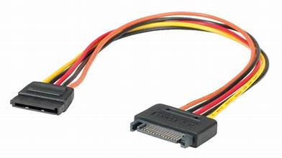
Purpose: Powers storage devices.
Devices Powered:
- SSD
- HDD
- DVD Drive
- Molex Connector
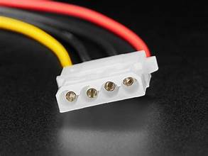
Purpose: Legacy power connector.
Devices Powered:
- Older hard drives
- Case fans
- LED accessories
- PCIe 6/8-Pin Connector
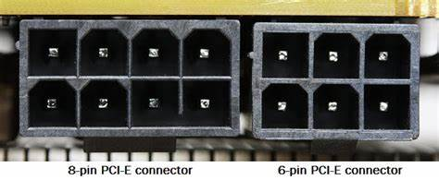
Purpose: Supplies extra power to graphics cards.
Devices Powered:
- Graphics Card (GPU)

TASK4. Imagine you are setting up a new gaming PC. List the steps you would follow to connect the SMPS to the motherboard, graphics card, and storage devices, mentioning which specific cables and connectors are used for each
Steps to connect SMPS in new PC:-
Step 1: Install the SMPS
- Place the SMPS inside the PC cabinet.
- Secure it using screws.
Step 2: Connect Motherboard Power
- Connect the 24-pin ATX connector from the SMPS to the motherboard.
Step 3: Connect CPU Power
- Connect the 8-pin (4+4) CPU power connector near the CPU socket.
Step 4: Install Graphics Card
- Insert the graphics card into the PCIe slot on the motherboard.
Step 5: Connect GPU Power
- Connect the PCIe 6-pin or 8-pin connector from the SMPS to the graphics card.
Step 6: Connect Storage Devices
- Install SSDs or HDDs.
- Connect SATA power connectors from the SMPS to each drive.
- Connect SATA data cables from the drives to the motherboard.
Step 7: Connect Additional Devices
- Connect Molex-powered fans or accessories if required.
Step 8: Check Connections
- Ensure all connectors are firmly seated.
- Organize cables using cable ties.
Step 9: Power On
- Connect the AC power cord.
- Turn on the PSU switch.
- Start the computer and verify all components are working.

